Creating A New Heaven And A New Earth

A Book of Meditations for Each Day in the Season of Advent 2023 created by the Communities of St Andrew’s, Abu Dhabi; St Martin’s, Sharjah; and Christ Church, Jebel Ali.

This Year’s Theme: Advent 2023 “Creating A New Heaven and A New Earth”
This year’s Advent reflections will refer to the theme from Isaiah 65:17-25.

Mother Christine (Senior Chaplain, St Andrews Church Abu Dhabi) has secured the rights to a serigraph by John August Swanson entitled “Peaceable Kingdom.”

The cover art will incorporate this artwork. Here is an excerpt describing the work: John Swanson’s much-loved serigraph the ‘Peaceable Kingdom’ was created in 1994 and has been out of print for over 15 years.

It is one of Swanson’s most popular images and embodies one of the central themes of his art: The hope is that people can live together in harmony, basing their lives on the Christian values of kindness, love, and peace.

“Peaceable Kingdom” is a visual illustration of Isaiah 11:6-8: “The wolf shall live with the lamb, the leopard shall lie down with the kid, the calf, and the lion and the fatling together, and a little child shall lead them...”

John Swanson’s creative, visual re-telling of this biblical vision enables us to see the story through new eyes and rediscover the power and meaning of the story for our own lives. He challenges us to look at our lives, to re-examine our worldview and see if we’re living as we should be.
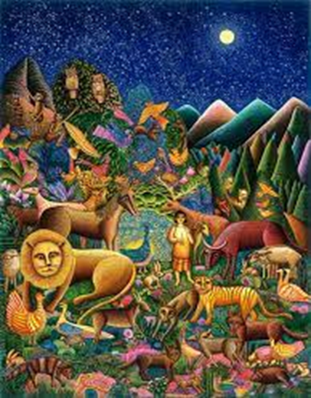

If you would be interested in receiving copies, please get in touch by emailing Rev. Gill Nisbet (gillnisbet@standrewauh.org) no later than 15th November 2023.

Many blessings and keep up the good work,

Sarel
The Barnabas Team – Resourcing the journey
www.cypgulf.org/retreats/
Anglican Diocese of Cyprus and the Gulf
2 Grigori Afxentiou,
Nicosia 1096, Cyprus
www.cypgulf.org
Office: +357 2267-1220 - Mobile: +357 9715-5092

