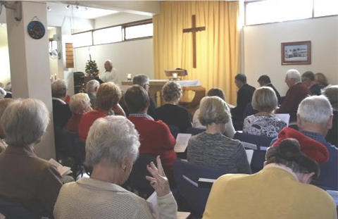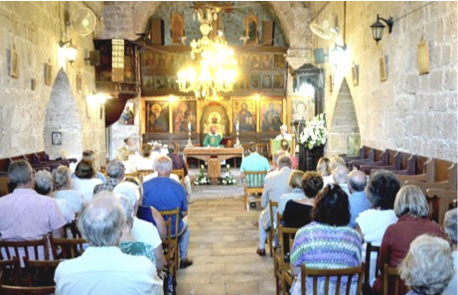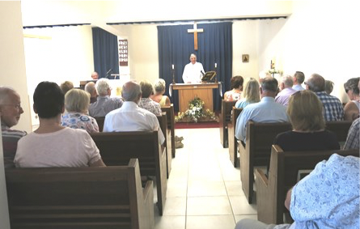
St. Stephen’s Ayia Kyriaki St. Luke’s
Tala Kato Paphos Prodromi

WEEKLY NEWS

Sunday 21st August 2022
(Trinity 10)

WELCOME
August is flying by, and so are a lot of clouds outside my window. Sorry to all those of you who went back to the UK to escape the summer heat only to be facing higher temperature in UK ! But we hear that it is returning to the normal British weather with rain and flash flooding hitting you over the last week. Here we remain in the 30C and very humid. Enjoy this week’s edition of the Weekly News.

PRAYERS FOR THIS WEEK
Collect:
Let your merciful ears, O Lord, be open to the prayers of your humble servants; and that they may obtain their petitions, make them to ask such things as shall please you; through Jesus Christ your Son our Lord, who is alive and reigns with you, in the unity of the Holy Spirit, one God, now and for ever. Amen.

A Prayer for this week for our Parish and Ourselves.
Heavenly father, we bless your name for this beautiful week ahead of us that you have prepared. We go with confidence in your name, bless the works of our hands as we strive to follow your commandment of ‘Love your neighbour’. You are a faithful God, and we commit all spheres of our life in your able hands, and ask you to make us fruitful in your name. As we go through the week, open our eyes to see new strategies for success and keep evil away from us. Thank you for answered prayers in Jesus name. Amen.

Psalm 1: 1-3
“Happy are those who do not follow the advice of the wicked or take the path that sinners tread or sit in the seat of scoffers, but their delight is in the law of the Lord, and on his law they meditate day and night. They are like trees planted by streams of water, which yield their fruit in its season, and their leaves do not wither. In all that they do, they prosper.”

Our Diocese:
See the downloadable Prayer Calendar here:
https://www.cypgulf.org/prayer-diary/

1
Daily Readings
For readings and the daily service of morning prayer, evening prayer and compline, please download https://www.churchofengland.org/prayer-and-worship/join-us-service-daily-prayer/daily-prayer-app-and-podcast

GOD SLOT
A friend said he’d found an article I’d written for a book about Self Supporting Ministers and I quote from it, “There we were looking ahead to an early retirement, touring Europe in our camper van enjoying the fruits of our labours. Early retirement?? God smiled and said I know just the thing!” And that’s how I ended up being your priest here on this beautiful island. It made me think about the journey to where we are now, and my plans compared to God’s plan. What about your experience and journey? Can you see where they differed to how you thought it was going to go? Let me know. On a completely different topic. I’m absolutely fed up with the news and newspapers being full of doom and gloom on every subject and it made me think that you’ve got to look around and see that there are more good things happening than evil, but they don’t get reported. Just think, God created this world for us to live in, not to survive on. Take a deep breath. Put down this magazine for a minute and stare out of the window. Enjoy what you see. Whatever it is, see it and value it as the precious gift of the created universe presented to you in this gracious moment. What a gift!
God Bless
Revd Ken

JOKE SPOT:
Little Johnny was an old farmer and one day a busload of politicians were driving down a country road, when suddenly the bus ran off the road and crashed into his barn. Little Johnny got off his tractor and went to investigate. Soon he dug a hole and buried the politicians. A few days later, the local policeman came out, saw the crashed bus and asked Little Johnny where all the politicians had gone. He told him that he had buried them. The policeman said, "Goodness, were they ALL dead?" Little Johnny said, "Well, some of them said they weren't, but you know how them politicians lie!"

DAILY PRAYER
Laura writes, “Reading your newsletter and seeing the blank space I have been puzzling what I could say that anyone might want to read. I thought maybe I could share this app I use daily:
Daily Prayer by Aimer Media Ltd.
https://apps.apple.com/gb/app/daily-prayer/id818491760

BLANK SPACE
You could have put an article or two in here!

BIKE NEWS
We’ve almost got enough in the kitty to get a fifth bike, this one will go to Joseph at St Luke’s. I’ve also got a promise of two bikes that just need a bit of TLC and they can go off to help someone soon. Well done folks.

NOTICES
WOOD FOR WINTER
The Donkey Holding Base has a quantity of free broken pallets, which can be used as firewood for the winter. The pallets can be broken down and if quantity is substantial they can be delivered. Also going free is an old fashioned hat/coat stand (like Granny had in the hallway). There are a number of plastic pallets that can be used as fencing, especially round trees, etc., which are €5 each. For more information please contact Gill Powell on 99331317.

2
MOONLIGHT CRUISE FROM LATCHI HARBOUR. THURSDAY 8TH SEPTEMBER
Join us on board the MS Koulla for an afternoon cruise returning in the moonlight. Boarding by 3.15 pm for prompt departure from Latchi pier at 3.30pm for the Blue Lagoon area. Returning by about 8pm. The price is €28 per person, payable to Chris Hoskins or Tim Sabben-Clare.

‘SONGS OF PRAISE’ AS THE SUN SETS
Join with us in the wonderful setting of Ayios Andronikos Park in Polis for the annual ‘Songs of Praise in the Park’ on Saturday 10th September at 5.30pm, organised by St Luke’s Church. This outdoor event, which has been running for many years, is an enjoyable occasion to sing well-known hymns and listen to memorable poems and readings on this year’s theme of ‘Faith’.

EVENTS
8th September Boat Trip from Latchi.
10th September Songs of Praise in the Park, Polis.
25th September Harvest Festival Lunch – Yannis, Kathikas
October Pet Blessing Service, outside Ayia Kyriaki
27th October Annual Sponsored Walk.
8th November Nicosia Coach Trip
26th November Barn Dance
10th December Carols for Christmas at St Luke’s
16th December Christmas Carols in the Kings Mall. (Singers required from all three churches)

SERVICES
Sunday 21st August
08.15am Sung Eucharist Ayia Kyriaki
11.00am Morning Worship St Luke’s
11.00am Holy Communion St Stephen’s
Readings:
Jeremiah 1: 4-10; Psalm 71: 1-6; Hebrews 12 : 18-29; Luke 13: 10-17

Sunday 28th August
08.15am Sung Eucharist Ayia Kyriaki
11.00am Holy Communion St Luke’s
11.00am Morning Worship St Stephen’s
Readings:
Jeremiah 2: 4-13; Psalm 81: 1, 10-16; Hebrews 13: 1-8, 15-16; Luke 14: 1, 7-14

Mid-week Holy Eucharist every Wednesday at 9.00am at Ayia Kyriaki

ONE HAIR HERE AND ONE HAIR THERE

The hairs of my head, God says are numbered,
But what an onus it is
For the one who must keep the accounting,
Because every day, the problem is,
The loss of hair keeps mounting.

Is it an angel who guards the tally?
It sure is a full-time job.
On the pillow, and on the shower floor –
It's enough to make an angel's head throb –
Each time I look, more and more!

3
Some of my friends, on top, are well tufted,
But some of us look like eggs.
Genetically, that's how we are disposed.
The "clear domes" have hair that has taken legs,
Which has left their tops exposed.

That's the way it is with no turning back,
But it's only a short while
Before to heaven, we zoom to that place,
And in that day I am going to smile,
'Cause there'll be perfect hair above my face.

These old bodies of ours will be remade
As perfection, we'll possess –
No pain, or illness, or death, or weeping;
No heartaches or problems, and no distress,
Found in the Lord's safe keeping.
(Ronald Ferguson)

Parish Priest:
The Reverend Ken Waters
telephone: 99 555290
email: anglicanpriest.acp@cytanet.com.cy
(Don’t forget Friday is my day off (most weeks))
Website:
www.paphosanglicanchurch.org
www.facebook.com/Anglican Church of Paphos
Weddings:
www.yourcypruswedding.org
www.facebook.com/Anglican Church of Paphos Weddings

4

