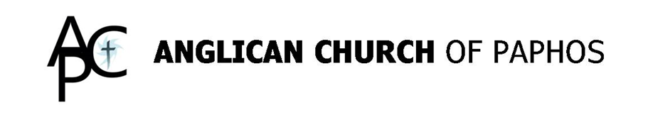

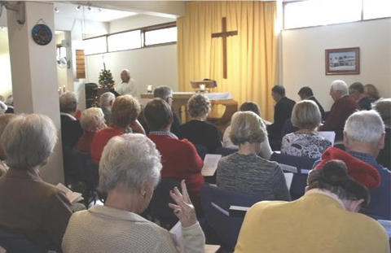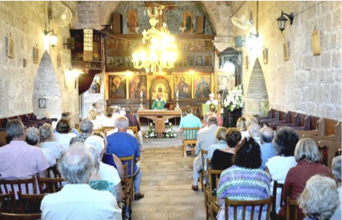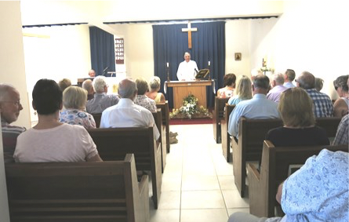
St. Stephen’s Ayia Kyriaki St. Luke’s
Tala Kato Paphos Prodromi

WEEKLY NEWS

Sunday 5th June 2022
(Pentecost/Queen’s Platinum Jubilee)

WELCOME
Hurrah, at long last, Wendy and I are finally free and both testing negative. I’ve missed you all . I’d like to thank Revd Andrew once again for going above and beyond to help out at this time. I’m really looking forward to getting back to ‘work’. It was driving me crackers being stuck in the house. I couldn’t even catch up on reading as the brain fog and all the sleeping doesn’t let you concentrate for too long. But that’s behind us now, so onwards and upwards.

PRAYERS FOR THIS WEEK
Collects:
The Queen.
Gracious God, we give you thanks for the reign of your servant Elizabeth our Queen, and for the example of loving and faithful service, which she has shown among us. Help us to follow her example of dedication and to commit our lives to you and to one another. Amen.

Pentecost.
God, who as at this time taught the hearts of your faithful people by sending to them the light of your Holy Spirit: grant us by the same Spirit to have a right judgement in all things and evermore to rejoice in his holy comfort; through the merits of Christ Jesus our Saviour, who is alive and reigns with you, in the unity of the Holy Spirit, one God, now and for ever. Amen

A Prayer for this week for our Parish and Ourselves.
May this new week allow God to shine upon us, may we dwell in the shadow of his wings, and his grace be sufficient for us in all that we do. May every crooked way be made straight; may our comings and goings be blessed; may the work of our hands be always for the work of the Lord. May we come to the end of the week having blessed and been blessed. Amen

Psalm 29: 11
“The LORD gives strength to his people; the LORD blesses his people with peace.”

1
Our Diocese:
See the downloadable Prayer Calendar here:
https://www.cypgulf.org/prayer-diary/

Daily Readings
For readings and the daily service of morning prayer, evening prayer and compline, please download https://www.churchofengland.org/prayer-and-worship/join-us-service-daily-prayer/daily-prayer-app-and-podcast

GOD SLOT
Life, as Christians, living together in a Christian community is not always easy. We are human after all, and while we may have God, for whom nothing is impossible, we forget and fail and fall out of love with God and each other. That’s why Jesus taught us how to deal with the fact that we will fail. Jesus’ teaching is first about reconciliation, restoration of a brother or sister to the community. It’s not about pointing out sin for the sake of it. It’s not about making us feel better or proving a point. It’s about repentance and forgiveness, for without that we perish. Jesus already died, horribly, so that we might have life. He hung on the cross for our sins so that we might have forgiveness and salvation. So Jesus is telling us how to win back those who seem lost. He’s telling us how to make his payment worthwhile. Our sins have been paid for. We have been redeemed. God, who knows every one of us, our weaknesses, our faults and failings, longs to draw us close to himself and one another. What a world we would live in if we could all reach this standard.
God Bless
Revd Ken

JOKE SPOT:
Little Johnny was at church and the Sunday School teacher was describing that when Lot's wife looked back at Sodom she turned into a pillar of salt. Little Johnny interrupted her by shouting out very excitedly, "My mommy looked back once while she was driving," he announced, "and she turned into a telephone pole." Disclaimer: Men have accidents too.

Growing old is inevitable, growing up is optional.

EVENING SERVICE AYIA KYRIAKI
Our first 6pm Holy Communion Service at Ayia Kyriaki is tonight, Sunday 5th June. This service will continue every first Sunday of the month until further notice. Do come along if you can.

WORLD DAY OF PRAYER
To mark the World Day of Prayer, a special service with the theme of ‘I know the plans I have for you’ will be held on Friday 24th June at 2.00pm at St Stephen’s, Tala. The service will include hymns, songs, readings, prayers and reflection. This is an annual occasion held throughout the world. The theme of the service is chosen by a different country each year, this year by the WDoP Prayer Committee from England, Wales and Northern Ireland. Everyone is welcome to attend and refreshments will be available after the service.
2
WEARING OF MASKS
From 1st June 2022 the rules for the compulsory wearing of masks has been lifted. An extract from the publication is shown below:
As of 1June 2022, the suspension of the mandatory use of a protective mask indoors and in closed spaces, excluding high-risk areas such as hospitals, senior people’s homes, closed structures of vulnerable groups, health care facilities (outpatient clinics, medical centres, rehabilitation centres) and public transport.
- It is recommended to use masks in places where large numbers of people congregate, for people who belong to vulnerable groups of the population and for people who interact with high-risk people.
I am happy for people to not wear masks if that is their preference. We will still maintain social distancing in the churches and I, and the Sacristan, will wear masks when administering the Host. The most important thing is that we all must feel safe in whatever we do.

NOTICES
Bible Study
Our next session will be on Monday 6^{h} June at St Stephen’s starting at 10.30am. Still time to join us, just give me a call and I’ll send you the homework.

EVENTS
24th June World Day of Prayer service at St Stephen’s, Tala
23rd July Annual BBQ in Peyia Forest
8th September Boat Trip from Latchi
10th September Songs of Praise in the Park, Polis
October Annual Sponsored Walk
16th December Christmas Carols in the Kings Mall

SERVICES
Sunday 5th June
Queen’s Jubilee Services
08.15am Sung Eucharist Ayia Kyriaki
11.00am Morning Worship St Luke’s
11.00am Holy Communion St Stephen’s
6.00pm Holy Eucharist Ayia Kyriaki
Readings:
Joshua 1: 1-9; Psalm 121; Romans 13: 1-10; Luke 22: 24-30

Sunday 12th June
08.15am Sung Eucharist Ayia Kyriaki
11.00am Holy Communion St Luke’s
11.00am Morning Worship St Stephen’s
Readings:
Proverbs 8: 1-4, 22-31; Psalm 8; Romans 5: 1-5; John 16: 12-15

Mid-week Eucharist every Wednesday at 9.00am at Ayia Kyriaki

Give Me a Sense of Humour

Lord, give me a sense of humour,
a spirit that is light . . .
so when I feel the dreariest
my heart can sparkle bright.
3
Let me learn to giggle,
when something tickles me
like my baby grandson
as I bounce him on my knee.

Let me learn to chuckle,
like I did as a little girl
even when life’s tangles
pull at my thinning curls.

Let me learn to laugh aloud,
even if only to myself . . .
like when a child is playing
with no one but them self.

Let me learn to smile,
when I prefer to wear a frown
like a toddler thick in mischief
and thinks no one is around!
(Deborah Ann)

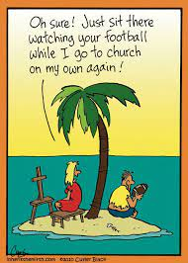

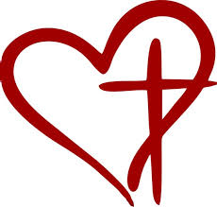

Parish Priest:
The Reverend Ken Waters
telephone: 99 555290
email: anglicanpriest.acp@cytanet.com.cy
(Don’t forget Friday is my day off (most weeks))

Website:
www.paphosanglicanchurch.org
www.facebook.com/Anglican Church of Paphos

Weddings:
www.yourcypruswedding.org
www.facebook.com/Anglican Church of Paphos Weddings

4

