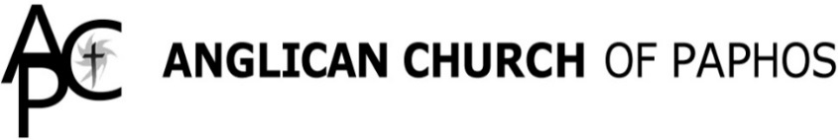

The Anglican Church’s
Funeral Ministry

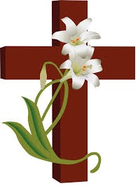

The death of a loved one or close friend is a traumatic moment. Here in the Anglican Church of Paphos, we would wish to extend to you our sincere condolences and sympathy. As well, we also provide practical help and advice which is available to all, in Paphos and the surrounding area, regardless of whether you are a member of our three churches.
The nature of our funeral service or memorial service will follow the Anglican (Church of England) pattern and will always be in English. We are flexible in what we can offer and can conduct services in one of our three churches (Ayia Kyriaki [beside St Paul’s Pillar – Kato Paphos] St Stephen’s Tala, and St Luke’s Prodromi) or at the graveside.
There is no crematorium on Cyprus, as yet, but we work closely with all local funeral directors, in particular, Angel Guardians Funeral Home, who offer a complete service which is very similar to what you would expect to find in the United Kingdom.
We also offer the services of a Funeral Ministry Coordinator who can offer practical advice both before the funeral takes place and on the day of the funeral. The funeral service will normally be conducted by one of the priests in the parish but our Readers, (licensed lay ministers) can also conduct a funeral service.
Considerable care will be offered, once you have contacted us, and we will ensure that the service follows your wishes particularly in regard to reading(s) tributes, hymns and music, if appropriate.
Contact: if you wish to inquire about funeral arrangements, please contact our Funeral Coordinator, Di Sylvester on 99 103976, email funerals@paphosanglicanchurch.org OR churchsecretary04@gmail.com
OR: VISIT OUR WEBSITE: www.paphosanglicanchurch.org
QUESTIONS THAT MIGHT BE ASKED:
What kind of funeral is possible here?
Broadly there are two kinds of funeral service: a graveside service or a service in a church followed by a committal at the graveside.
- There is no crematorium on Cyprus, as yet.
- Unlike a few years ago, Paphos has an excellent undertaking team at Angel Guardians Funeral Home and they will take charge of the practical arrangements concerning a funeral. They are a firm run by British ex-pats but are well resourced to provide funeral arrangements for British expats, Cypriots and those of other nationalities. There are, also, other firms in
Paphos such as Galinis (opposite the General Hospital) and firms in Limassol who will also arrange funerals in Paphos.
- When arranging the time of a funeral, it is important to remember that even in spring and autumn the weather can be very hot for mourners standing in the sun, and occasionally the problem of torrential rain has to be dealt with.
Where would I be buried?
Ex-pat residents can now be buried in local cemeteries but you will generally have to show that you have lived in the area where you wish your loved one to be buried. You may need your local Mukhtar’s help to achieve this and a local undertaker will be able to assist you. It is also possible for people with a British passport and their spouses to be buried at the British Cemetery at Erimi – not far from Limassol. It is run by trustees as a non-profit making charity.
May we design a funeral to suit the deceased and our family?
Yes, the officiating priest, along with your undertaker, will help you co-ordinate every detail of a service and burial including: church venue, readings, music, flowers, burial in a cemetery and charitable donations etc.
Can we have music at a funeral?
Our organist can play for a funeral at any of our three churches. There is an additional fee for an organist. Due to rulings by the Greek Antiquity’s Department, no recorded music can be played at our historic church of Ayia Kyriaki. Recorded music can be played at the graveside and both recorded music or organ music in our churches at St Stephen’s (Tala) and St Luke’s (Prodromi).
Do you bury ashes?
Yes, if a cremation has taken place outside Cyprus, the cremated remains can be buried in the British Cemetery at Erimi.
I can’t get to the funeral in my home country
Why not come to the church at the time of the funeral either to pray privately? Or we can arrange to be with you and to pray with you. This is increasingly common and a very meaningful practice.
Do Anglicans have memorial events like the Orthodox?
Once a year, usually the Sunday before or after 1st November at 6pm, at Ayia Kyriaki, we have a Service of Thanksgiving and Remembrance. Names of loved ones who have died are read aloud and names may be recalled silently at this service. All are welcome.
What’s the difference between a funeral and a memorial service and does the Church do both?
A funeral takes place with the deceased’s coffin present while the absence of the coffin makes it a memorial service which occurs after a funeral has been held. The Anglican Church of Paphos is happy to arrange memorial services.
How much does a funeral cost?
The costs depend on what you choose, as the options vary from a simple graveside burial service conducted by a priest to a church funeral and a burial service at the graveside. The Funeral Co-ordinator or the officiating priest will inform you of all the costs involved and discuss them with you so that you can decide.
Do we have to wear black to the funeral? This is the custom in Cyprus, but it is not required by the Anglican church. Given the heat in summer, it is appropriate to wear lighter clothing, but out of respect, it is appropriate for women to cover their shoulders for a church service. Often families encourage their friends to wear bright colours to a funeral and this is perfectly acceptable.
May we contact the ministry team after the funeral if we need additional help?
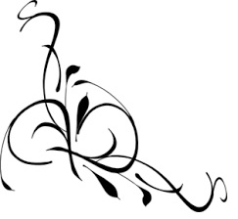
Yes, certainly – they will keep in touch with you and offer you any additional assistance you may need. In particular, they can put you in touch with a bereavement counsellor if you feel the need to talk about your loss.
For more information, contact:
Di Sylvester (Funeral Coordinator)
on 99 103976, OR The Reverend Ken Waters, Parish Priest, on 99 555290. www.paphosanglicanchurch.org
Updated October 2021

